Unit 5
WAVE ANALYZER AND DIGITAL INSTRUMENTS
- Wave Analyzer
A wave analyzer is instruments designed to measure the relative amplitude of signal frequency components in a complex or distorted waveform. They provided a graphical representation of signal amplitudes versus frequency, known as spectrum. It is also called signal analyzer.
Basic wave-analyzer: The basic wave analyzer mainly consists of three blocks;
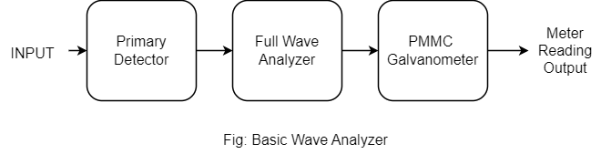
- Primary Detector
It consists of an LC circuit, we can adjust the value of ‘L’ and ‘C’ in such a way that it allows only the desired harmonic frequency component that is to be measured.
- Full-wave Rectifier
It converts the AC input into DC output.
- PMMC Galvanometer
It shows the peak value of signal which is obtained at the output of full wave rectifier. Now, the corresponding components of above block-diagram, is the basic wave analyzer will shown as:
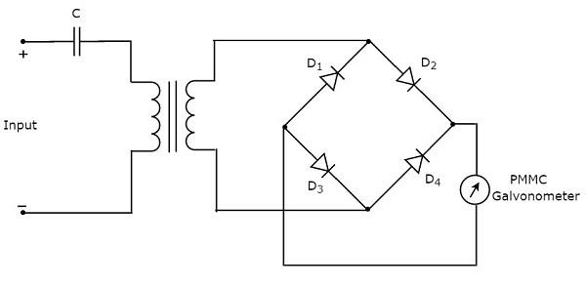
This basic wave analyzer can be used for analyzing each and every harmonic frequency components of periodic signal.
Types of wave analyzer:
5.1.1 Frequency Selective Wave Analyzer
The wave analyzer used for analyzing the signals is of 20 Hz to 20 KHz audible frequency range.
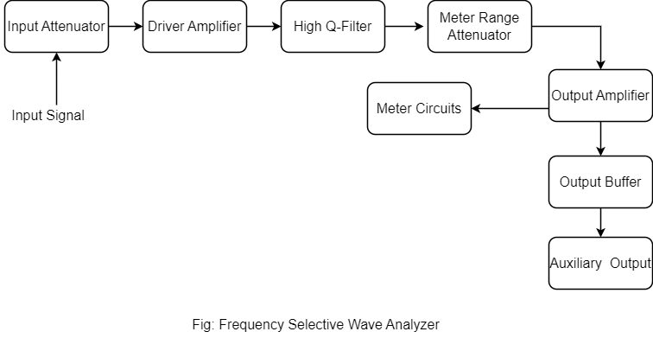
- Input Attenuator
The AF signal, which is to be analyzed, is applied to input attenuator, if signal amplitude is too large than it can be attenuated by input attenuator.
- Driver Amplifier
It amplifies the received signal when it is necessary.
- High Q-Filter
It is used to select the desired frequency and rejected unwanted frequencies. It consists of two filter amplifier and all these are cascaded with each other.
- Meter Range Attenuator
It gets the selected AF signal as an input and produces an attenuated output whenever required.
- Output Amplifier
It is used to provide the selected AF signal to output buffer if necessary.
- Output Buffer
It is used to provide the selected AF signal to output devices.
- Meter Circuit
It displays the reading of selected AF signal. We can choose the meter reading in volt range or decibel range.
5.1.2 Heterodyne Wave Analyzer
The wave analyzer used to analyze the signals of RF range is called super heterodyne or heterodyne wave analyzer.
Working of Heterodyne Wave Analyzer:
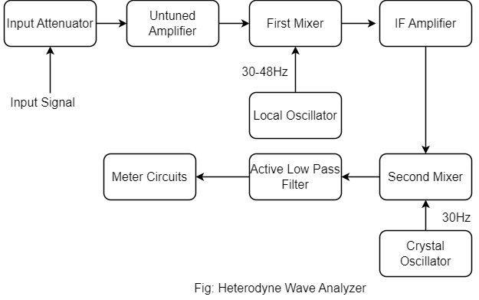
- The RF signal, which is given to input attenuator. If the signal amplitude is too large, then it can be attenuated by input attenuator.
- Untuned amplifier amplifies the RF signal whenever necessary its applied to first mixer.
- The frequency ranges of RF signal and the output of local oscillator are 0-18 MHz and 30-48 MHz respectively. So, first mixer produces an output which has frequency of 80 MHz this is difference of frequencies of the two signals that are applied to it.
- The cut-off frequency of active low pass filter is chosen as 1500 Hz. Hence, this filter allows the output signal of second mixer.
- Meter circuit displays the reading of RF signal. We can choose the meter reading in volt or decibel range.

- Spectrum Analyzer
It is a device that measures and displays signal amplitude as it varies by frequency within its frequency range [Spectrum]. The frequency appears on the horizontal X-axis and the amplitude is displayed on the vertical Y-axis. It looks like an oscilloscope and in fact some device can function as either oscilloscope or spectrum analyzer.
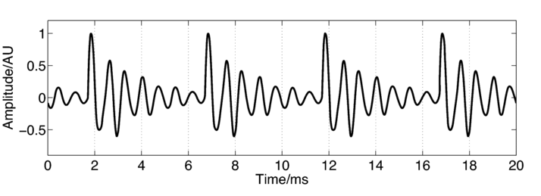
OR
Spectrum analysis of signal spectrum analysis is defined as study of energy distributions across the frequency spectrum of given electrical signal. Study gives information about bandwidth, effect of different types of modulation and spurious signal generation. Knowledge of these quantities is useful in the design and testing of radio frequency and pulse circuitry.
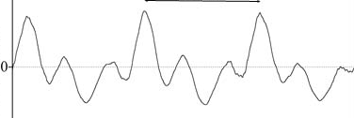
Spectrum Analysis:
- Audio frequency analysis [20 HZ - 20 KHz]
- Radio frequency analysis [10 MHz -20 GHz]
- Spectrum analysis is instruments which are capable of portraying graphically amplitude as a function of frequency in the RF spectrum.
Applications:
- Measurements of attenuation
- Measurements of FM deviation
- Measurement of frequency in pulse studies.
Types of Spectrum Analyzers:
These instruments provide a display of frequency spectrum over a given frequency band spectrum analyzers use either a parallel filter bank or swept frequency technique. So, we can classify the spectrum analyzers into following types.
5.2.1 Basic Spectrum Analyzer using Swept Receiver Design
The spectrum analyzer used for analyzing the signals are RF range is called super heterodyne spectrum analyzer.
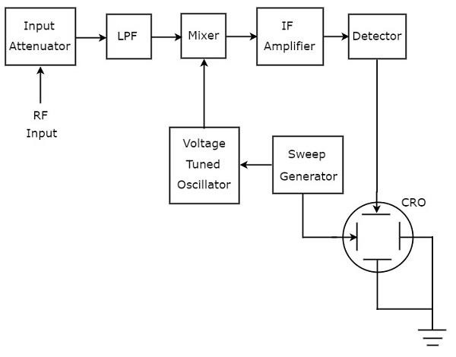
Working Principle:
- The sweep generator or saw-tooth generator provided the saw-tooth voltage which drives the horizontal axis of elements CRO, and saw-tooth voltage is frequency controlled elements of the tunes oscillator. As oscillator sweeps from f_{min} to f_{max} of its frequency band at linear recurring rate. Its beats with the frequency components of the input signal produced on IF.
- The RF signal, which is to be analyzed, is applied to input attenuator. If the signal is too large then it can attenuated by an input attenuator.
- Low pass filter [LPF]; it only sends the less than the cutoff frequency.
- Mixer gets the input from LPF and voltage tuned oscillator and its produced output which difference of frequency signals.
- IF amplifier amplifies the IF signals. The output o mixer, the IF signal is applied to detector. The output of detector is given to Y-axis of CRO that means vertical deflection plate of CRO, So, that CRO displays the frequency spectrum of RF signals on its CRT screen.

5.2.2 IRF Spectrum Analyzer OR Parallel Filter Bank Analyzer
An IRF spectrum analyzer is a device used to analyze and display the frequency spectrum of intermediate frequency signals. I commonly used in communication system and electronic equipments for signal analysis and troubleshooting. In parallel filter bank analyzer the frequency range is conversed by a series of filter whose central frequencies and bandwidth are so selected that they overlap each other. The spectrum analyzer used for analyzing the signals are AF range is called filter bank spectrum analyzer or real time spectrum analyzer because it shows any variation in all input frequencies.
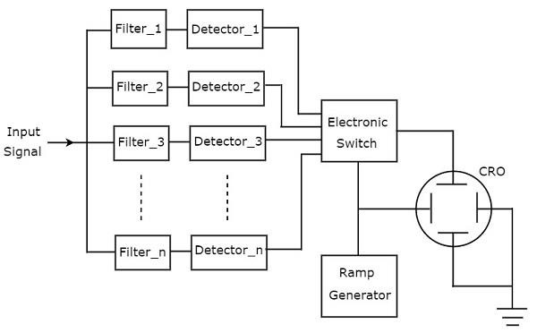
Working Principle:
- It is set of band pass filters and each one is designed for allowing a specific band of frequencies. The output of each band pass filter given to detector.
- All the detector output is connected to electronic switch. This electronic switch allows the detector output sequentially to the vertical deflection plate of CRO. So, CRO display the frequency of AF signals on its CRT screen.

- Distortion Analyzer:
A distortion analyzer is a specialized electronic test instrument used to measure and analyze distortion in audio and radio frequency (RF) signals. It provides valuable insights into the quality and fidelity of audio and RF systems by quantifying the level of distortion introduced during signal processing, transmission, or amplification.
- Harmonic Distortion Analyzer
A harmonic distortion analyzer is a specialized electronic test instrument used to measure and analyze harmonic distortion in audio and radio frequency (RF) signals. It quantifies the amplitude of harmonic components present in the output signal compared to the fundamental frequency, providing insights into the linearity and fidelity of audio and RF systems.

- Fundamental Suppression Type
Distortion analyzer measures the total harmonic power present in the test wave rather than the distortion caused by each component. The simplest method of suppress the fundamental frequency by means of high pass filter whose cutoff frequency is a little above the fundamental frequency. Thus, the high pass filter allows only the total harmonic to pass and the total harmonic distortion (THD) can measured. The most commonly used harmonic distortion analyzer based on fundamental suppression are as follows:
- Using High pass Filter
A harmonic distortion analyzer measured the total harmonic power present in the test wave. Not distortion caused by each individual component. The simplest method is to suppress the fundamental frequency by means of high filter whose cutoff frequency is little greater than fundamental frequency. Hence, it falls in stop-band. This high pass filter allows the harmonic which are in pass band. Hence, the total harmonic distortion can measure.
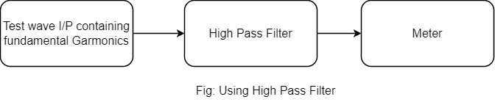
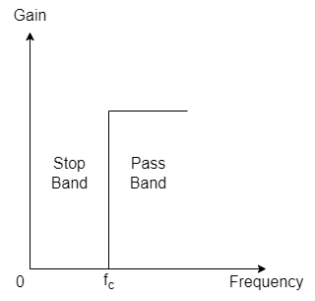
- Resonance Bridge Type
This bridge circuit is balanced for the fundamental frequency i.e. ‘L’ and ‘C’ are turned to the fundamental frequency. The fundamental energy is dissipated in the bridge circuit elements. The bridge is unbalanced for the harmonics and only harmonics passed through the bridge. Hence, the harmonic power is available at the output terminals and can be measured on meter.
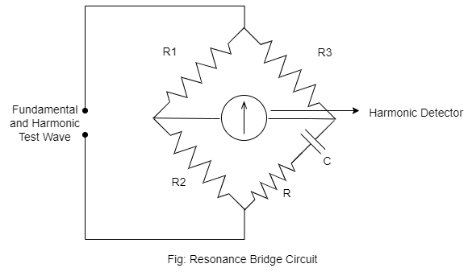
- Measurements of Frequency and Time: Decimal Count Assembles
Measurement of time [Period Measurement]
In some cases it is necessary for digital measurement of time rather than frequency. This is especially true in the measurement of frequency in the low frequency range. To obtain good, accuracy at low frequency, we should measure the period rather than make direct frequency measurements. The circuits used for measuring frequency can be used for measurement of time period if the counted signal is interchanged.
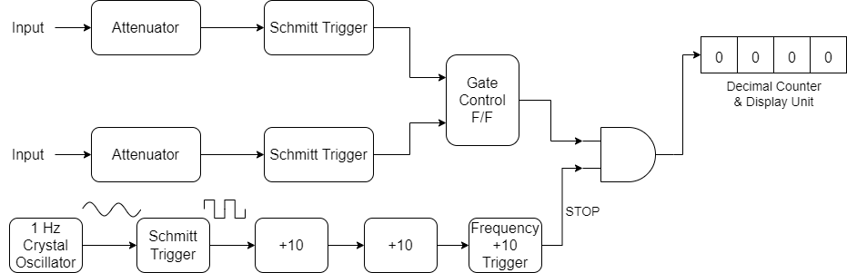
The figure shows that circuit for digital measurement of time period. The getting signal is derived from the unknown input signal, which now controls the enabling and disabling of the main gate. The no. of pulses occur during one period of the unknown signal are counted and displayed by decode counting assemblies. The disadvantages of this system are measuring the low frequency range. The operations have to calculate the frequency from the time by using equation.
$$f=\frac{1}{T}$$
For example: When measuring the period 60 Hz frequency, the electronic counter might display 16.6673ms.
$$f=\frac{1}{T}=\frac{1}{16.6673×{10}^{-3}}=59.9977 Hz$$
- Frequency Counter
It is an electronic instrument that is used to measure frequency and time. Frequency counters are used for a wide range of frequency and time measurements and display many digits of accuracy frequency counter helps to measure the time required digital signals and the frequency correctly and associates with wide range of radio frequencies. In other words, these are essential instruments that count the number of cycle per seconds of an input signal. These are used n electronic and telecommunications industries to measure frequency bandwidth, peak to peak voltage or current or rise time frequency counters count the pulses and transfer them into frequency counter when the member of pulses events occur in a period and display it on the frequency range of vibrations. The counter then set to zero frequency counters are after found in built into other devices such as radio receivers, radar set and test equipments. It is device that is easy to use, measure the frequency accurately and displays it digitally.
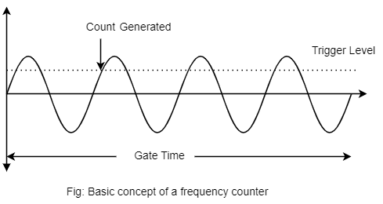
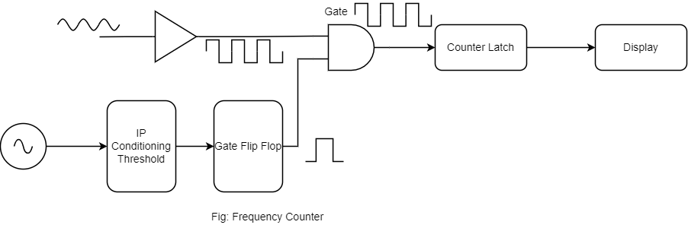
- A frequency counter measures signal in the first split into the pulses setting. It operates by counting the number of times the signal passes through the voltage point to a trigger point in duration.
- The trigger of frequency counters start at zero crossing point automatically. It is device that sets in a clock speed with pulse per unit cycle and the pulses present to the device for a limited time.
- After this, vibration/pulses apply in a definite interval of time, counts the pulse.
- An electric counter does the whole process and the pulses are sent to the cycle to represent the unidentified signal and give it a value.
- The frequency counter works on two modes to generate the pulses and time delay.
- Whenever we talk about the working of the frequency counter then the pulse in this device generates from the wave generation or microcontroller. The timer in this device figures as a counter.
- It sets the count of the pulses from high and low. The final count of the pulses takes place.
- The device that converts the resultant by multiplying it by ten frequency cycles per second convert value of the pulses in hertz. After the whole calculations inside the frequency counter. The frequency of the pulses becomes visible on the LCD or LED.
Types of Frequency Counter:
- Bench Frequency Counter
It is a type of device that useful in applying electronic test equipment. It measures the period and equal frequency precisely. This device is also known as for reducing measurements error due to temp drift. This device used in electronic lab and electronic project for measuring frequency of periodic signals.
- PXI Frequency Counter
PXI frequency counter is useful in the control system and track system for tests. It is measuring the frequency and phase of an input signals per reference signal. Its application is mainly to audio, video and RF signal. For different application of device is testing microwave circuit wireless device and antennas.
- Handheld Frequency Counter
It helps to measure the frequency of cycles per second of a periodic waveform in the signal. It provides precise measurement of output application of this device to measure the radio frequencies.
- Panel Meter
A panel meter is type of frequency counter available in panel mount mode. Its applications in determining the frequency of audio and radio signals.
- Period Counter
A period counter is an electronic test instrument used to measure the time interval of periodic signals, typically expressed as the period between successive cycles of the signal. It is commonly used in electronic testing and measurement applications to determine the frequency, duty cycle, and other timing parameters of periodic waveforms.
Features:
- Time Measurement: Period counters are designed to accurately measure the time interval between consecutive rising edges, falling edges, or zero crossings of a periodic signal. They provide a numerical readout of the period in units of time, such as seconds, milliseconds, microseconds, or nanoseconds.
- Frequency Calculation: By calculating the reciprocal of the period, period counters can also determine the frequency of the input signal in hertz (Hz) or kilohertz (kHz). Frequency measurements are essential for assessing the performance and behavior of oscillators, clocks, and other periodic signal sources.
- High Resolution: Period counters often offer high resolution and accuracy, enabling precise measurement of short time intervals and high-frequency signals. They may have adjustable measurement settings to optimize resolution and accuracy for different signal types and frequencies.
- Input Sensitivity: Period counters feature input circuits with high sensitivity and impedance to detect and measure weak or low-level signals accurately. They may provide adjustable input coupling options (AC/DC) and input impedance settings to accommodate various signal sources and measurement scenarios.
- Triggering Options: Period counters may offer triggering options to synchronize measurements with specific events or signal conditions. Triggering capabilities help capture and analyze periodic waveforms with precise timing control, enhancing measurement accuracy and repeatability.
- Error: Counter Error and Signal Related Error
- A counter error typically indicates a problem or discrepancy in the frequency or time measurement performed by the wave analyzer counter. The counter is responsible for counting the number of cycles or events within a given time period.
- A counter error might occur if there are issues with the counter circuitry, calibration or if the signal being measured is outside the counters measurements range. In such cases, the accuracy and reliability of the frequency or time measurement may be compromised.
- A signal related error generally refers to an error or issue related to the input signal being analyzed by the wave analyzer. This can include various factors, such as noise, distortion, interference or improper signal conditioning signal related errors can affect the accuracy of measurements and distorts the wave for being analyzed and leading to incorrect or unreliable.
- Digital Voltmeter (DVM)
It displays the voltage reading of circuits numerically which used to measure the electrical potential difference between two point in the circuit.
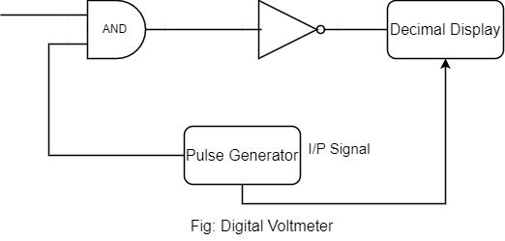
Working:
- Unknown voltage signal is fed to the pulse generator which generate a pulse whose width proportional to the input signals.
- Output pulse generator is fed to one leg of the AND gate.
- The input signal to other leg of the gate is a train of pulse.
- Output of AND gate is positive triggered train of duration same as the width of the pulse generated by the pulse generator.
- This positive triggered train is fed to the inverter which converts it into a negative triggered train.
- Output of an inverter is fed to a counter which counts the number of trigger in the duration which is proportional to the input signal i.e. voltage under measurements.
- Counter can be calibrated to indicate voltage (V) directly.
The working of digital voltmeter that is nothing but acts as analog to digital converter which converts analog signal into a train of pulses. The digital voltmeter to A/D conversion methods;
Types of Voltmeter:
5.8.1 Ramp type digital voltmeter
The ramp type DVM, the operation basically depends on the measurements of time. The times which the ramp voltage takes to change from the level of the input voltage to that zero (0) voltage or vice-versa.
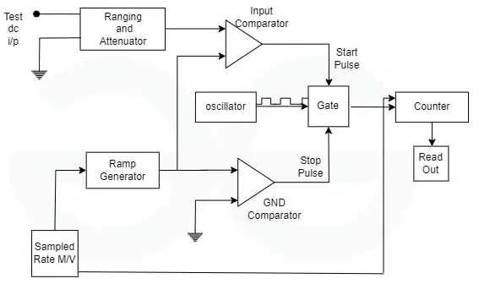
It shows the “voltage-to-time” conversion using gated clock pulses. At staring of cycle, a ramp voltage is initiated this voltage positive going to negative going. The negative going ramp continuously compared with unknown input voltage. At the instant that ramp voltage equals the unknown voltage and coincidence circuit or comparator generates a pulse which opens a get. The ramp voltage continues to decrease with until it finally reaches 0V [ground pot] and 2nd comparator generates an output which closes the gate.
An oscillator generates clock pulses which are allowed to pass through the gate to a number of decade counting units (DCUs) which totalize the number of pulses passed through the gate. The decimal number displayed by indicator tubes associated with the DCUs is a measure of the magnitude of the input voltage.
The sample rate multi-vibrator [MV] determines the rate at which the measurements cycle are initiated. The sample rate circuits provided an initiating pulse for the ramp generator to start its next ramp voltage. At the same time a reset pulse is generated which return all DCUs to their zero state, removing the display momentarily from the indicator tubes.
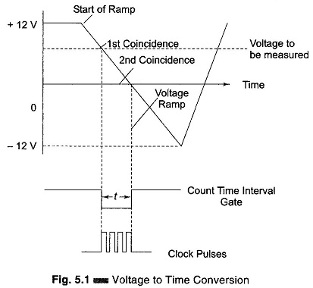

5.8.2 Integrating type digital voltmeter (Voltage to Frequency Conversion)
This voltmeter indicator the true average value of the unknown voltage over a fixed measuring period it employs an “Integration technique” which uses a voltage to frequency (V/F) conversion. The V/F converter function as a feedback control system which governs the rate of pulse generation in proportion to magnitude of the input voltage. In voltage to frequency conversion technique, a train of pulses is generated. The frequency of pulse depends on the voltage being measured. These pulses are counted that appears in a definite time interval. After all, the frequency of pulses is a function of input voltage the number of pulses is an indication of the input voltage.
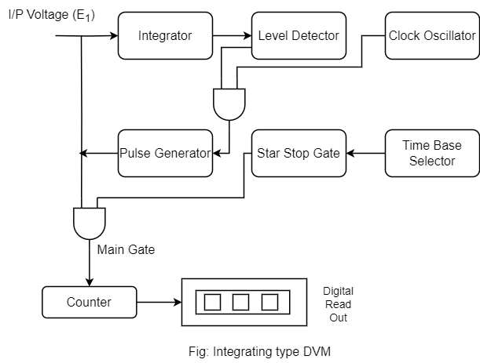

5.8.3 Servo Potentiometer type digital Voltmeter
A potentiometer type DVM employs voltage compression technique. In this DVM, the unknown voltage is compared with reference voltage whose value is fixed by setting of the calibrated pot. The pot setting is changed to obtain balanced when null conditions are obtained the value of the unknown voltage is indicated by the dial setting of the potentiometer. In pot type DVM, the balanced is not obtained manually but is arrived at automatically. This type of DVM is called self-balancing pot. The pot DVM is provided with read out which displays the voltage being measured.
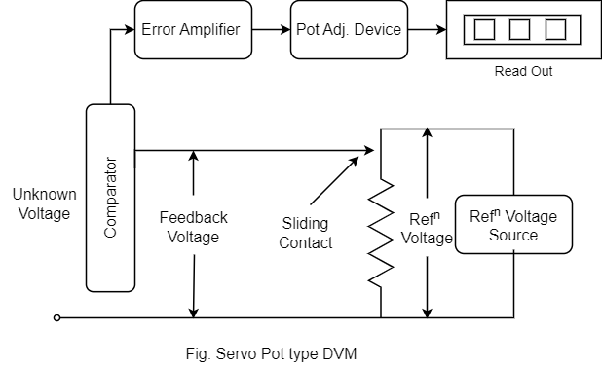

5.8.4 Successive Approximation type digital Voltmeter
A digital to analog [D/A] converter is used to provide the estimate. The “equal to or greater than or less than” decision is made by the comparator. The D/A converter provide the estimate and are compared to the input signal. The successive approximation resister [SAR] is used to control the D/A converter and consequently the estimates. At the beginning of the conversion all the estimate is greater than the input, the comparator output is high and the first SAR output reverse, state and second output changes logic ‘one’ if the comparator output is low, indicating that the estimate is lower than the input signal the first output remain in the logic one state. This continues to all the states until the conversion is complete.
The above sequence of events is performed electrically. For an N-bit conversion after N-clock the actual value of the input is known. The least significant bit is the state of the comparator. In some system an additional clock is employed to store the last bit in SAR and thus N+1 clock are required for a conversion.
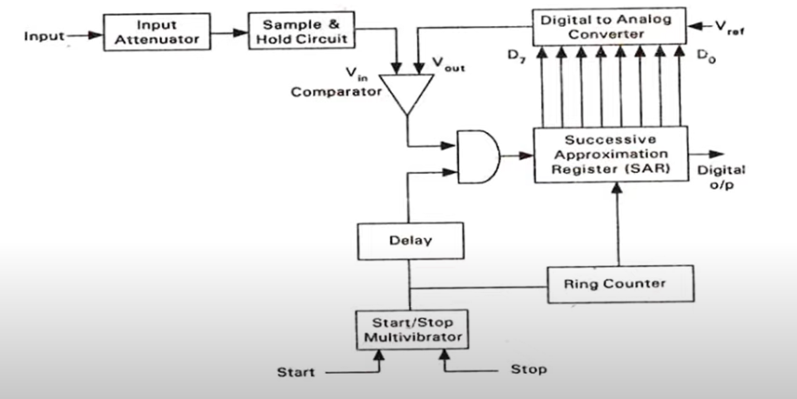
- Vector Voltmeter
Voltmeter is specialized instruments used for measuring complex voltage quantities particularly in RF [Radio Frequency] and microwave systems. It is designed to measure both the magnitude and phase of complex voltage or vector quantity. Like a std. voltmeter that measures only the amplitude of voltage signal, a vector voltmeter provides additional information about the phase or angle of the voltage. This is particularly useful in application where the phase relationship between multiple voltage signals is critical, such as in RF signal analysis, and network analysis or impedance measurements.
The vector voltmeter typically consists of two channels; an in-phase channel and quadrature channel. The phase channel measures the real or resistive component of voltage while quadrature channels measures the imaginary or reactive component of the voltage.
By processing the measurements from both channels the voltmeter can calculate the magnitude and phase angle of complex voltage. It can display these values in various formats such as polar coordinates [magnitude and angle] or rectangular coordinates [real or imaginary components].
Vector voltmeter is commonly used in RF and micro wave Engg. for task like impedance matching, network analysis, phase measurement and evaluating the performance of RF system.
- Digital Multi-meter (DMM)
A digital multi meter [DMM] is a Test tool which measure two or more electrical components like voltage (V) current [Amp.] and resistance [Ω or Ohm]. It is std. tool for electrical and electronics measurement system.
Digital multi meter combines the testing capability of single-task meters. The voltage (V) measure for volts, ammeter (Amp.) and Ohmmeter (Ohm), advance options also available in DMM.
DMM include Components:
- Display: Read out the value.
- Buttons: Selects the various functions.
- Dial (Rotary Switch): For selecting primary
- Input Jacks: Where the test leads are inserted. Two lead [Red for positive and Black for Negative] that plug into the DMM. The probe tips on each lead are used for testing circuit.

- Computer Based Digital Instruments [IEEE-488 GPIB Instruments]
Now a day’s automatic test equipments is one of the leading method for testing electronic equipments in factory production and troubleshooting situations. The basic method is to be use a programmable digital computer to control a bank of test instruments. The bank of instruments can be configured for a purpose or for general use.
The IEEE-488 bus or General Purpose Interface Bus [GPIB] is a tool that is based on the Institute of Electrical and Electronics Engineers [IEEE]. The digital signals on IEEE-488 bus are generally similar to TTL [Transistor-Transistor Logic] i.e. logic low is less than 0.8V and logic high is greater than 2.0V.
The digital signal can be connected to the instruments through a multi conductor cable up to 20 meters is length provided that an instruments load is placed every 2-meter. Most IEEE-488 bus/GPIB system operates unrestricted to 250 kilobytes per seconds or faster with some restrictions.
There are two basic configurations for the IEEE-488/GPB system;
- Linear
In this type of configurations a tap-off to next instruments is taken from the previous one in series.
- Star
In this case, the instruments are connected from a central point.
The basic structure of IEEE-488/GPIB system, the figure indicates the following four different devices;
- Computer
- Frequency Counter
- Signal generator
- Digital Multi meter
The IEEE-488/GPIB system itself consists of three major buses;
- General Interface Management [GIM] bus
This bus coordinates the whole system and ensures an orderly flow of data over data I/P O/P [DIO] bus.
- Data I/O [DIO] Bus
This bus is a bi-directional 8-bit data bus that carries data interface message and device dependent message between the controllers, talkers and listeners. This bus sends asynchronously in byte serial format.
- Data Byte Transfer [DBI] bus
This bus controls the sending of data along the DIO bus.
- The signal defined for above three buses is implemented as conductor in a system interface cable.
- Each IEEE-488/GPIB system [i.e. computer, frequency counter, signal generator and digital multi meter] are categorized as;
- Controller
It is function is to communicate device addresses and other interface buses to instruments in the system.
- Listener
Its function to receive commands from the other instruments [usually the controller] when the correct address is placed on the base. The listener acts on the message received but does not sent back any data to the controller.
- Talker
It is function to respond to the message sent to it by the controller. VXI bus is another widely growing platform for instrumentation system. The VXI back plane include the 32-bit VME data bus high performance instrumentations buses for precision timing and synchronization between instrument components.
